Car Game:
https://github.com/davidmonterocrespo24/esp32s3-arcade-3d

MCU | ESP32-S3, 240 MHz dual-core, 8 MB PSRAM
Select devboard esp32-S3 Dev Module
8MB flash size
Enable PSRAM
Huge file system
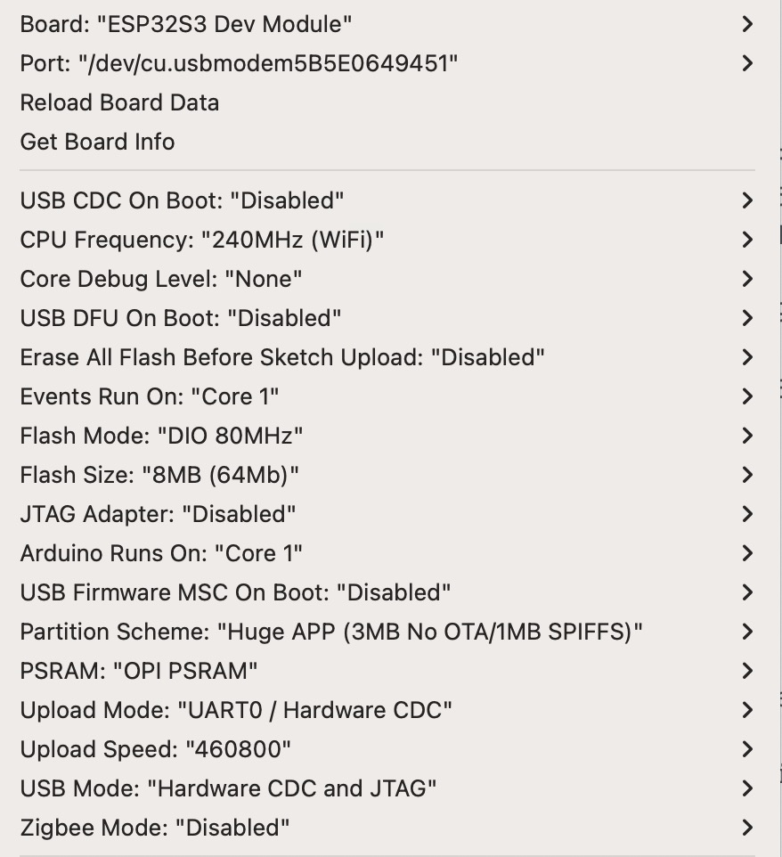

For uploading code Plugged into COM USB-C port

GPIO:

TFT:
#define TFT_MOSI 11
#define TFT_SCLK 12
#define TFT_MISO 13
#define TFT_CS 10
#define TFT_DC 9
#define TFT_RST 8

Controller GPIOs:
#define BTN_LEFT 16
#define BTN_RIGHT 17
#define BTN_TURBO 0
#define BTN_4 15 // Reserved — wired but not yet assigned a function
#define JOYSTICK_X 4 // Analog — left/right axis
#define JOYSTICK_Y 5 // Analog — forward/back axis
#define JOYSTICK_Z 7 // Digital — press button (unused, reserved)

